**Task No # 1:** Create a temperature converter using JavaScript. Then apply a formula to convert Fahrenheit to Celsius.

**Formula:**

* **Celsius = (Fahrenheit -32) * 5 / 9;**

Solution:

<!DOCTYPE html>

<html lang="en">

<head>

    <meta charset="UTF-8">

    <meta http-equiv="X-UA-Compatible" content="IE=edge">

    <meta name="viewport" content="width=device-width, initial-scale=1.0">

    <title>Document</title>

    <script>

        function myfunction(){

            const far=parseFloat(prompt("Enter fahrenheit Temperature"));

        let result;

        result=(far-32)*0.55;

        document.write("Celcius temperature is=" + result)

  }

    </script>

</head>

<body>

    <input type="button" onclick="myfunction()" value="Click here">

</body>

</html>

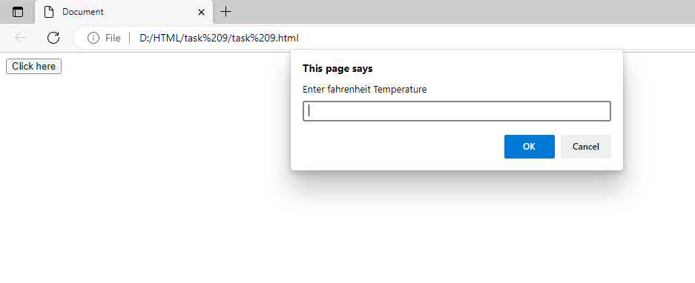

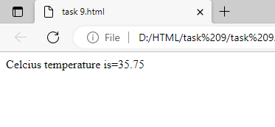

**Task No#2:** Take two inputs from the user using the prompt box. Ask the user to choose any one of the following operations.

1. addition
2. subtraction
3. multiplication
4. division

Solution:

<!DOCTYPE html>

<html lang="en">

<head>

    <meta charset="UTF-8">

    <meta http-equiv="X-UA-Compatible" content="IE=edge">

    <meta name="viewport" content="width=device-width, initial-scale=1.0">

    <title>Document</title>

    <script>

        function myfunction(){

        var num1=parseFloat(prompt("Enter fisrt Number"));

        var num2=parseFloat(prompt("Enter Second Number"));

      var opt=prompt("Please Enter the operator +,-,/,*");

      let result;

      if(opt=="+")

      {result=num1+num2;

        document.write("Addition is="+result);

      }

      else if(opt=="-")

      {result=num1-num2;

        document.write("Substraction is="+ result);

      }

      else if(opt=="/")

      {result=num1/num2;

        document.write("Division is="+result);

      }

      else if(opt=="*")

      {result=num1*num2;

        document.write("Multiply is="+result);   }}</script>

</head>

<body>

<input type="button" onclick="myfunction()" value="Click here">

</body></html>

